Shree Saraswati Secondary School

Melamchi-1 Bhotechaur, Sindhupalchok

Pre-Examination-2081 (First Term)

Time: 2 hrs. Class: 9 Subject: C. Math Full Mark: 50

Answer all the questions.

1. If $U=\left\{x:x<10, x∈Ν\right\}, A=\left\{x:x≥5\right\}, B=\left\{odd numbers\right\} and C=\left\{prime numbers\right\}then,$
2. Write the given sets by listing method. [1]
3. Show the given sets in Venn-diagram. [1]
4. Prove that: $A∩\left(B∪C\right)=\left(A∩B\right)∪\left(A∩C\right).$ [3]
5. Which of the set represent singleton sets and why? [1]

|  |  |
| --- | --- |
| For Sole Proprietorship Firm | |
| Annual Income | Tax Rate |
| Up to Rs. 5,00,000 | Tax Free |
| Additional Rs. 2,00,000 | 10% |
| Additional Rs. 3,00,000 | 20% |
| Additional Rs. 10,00,000 | 30% |
| Any additional amount  Above Rs. 20,00,000 | 36% |

1. Bikash has a sole proprietorship firm. He earns Rs. 22,00,000 from the firm annually. If he pays monthly Rs. 2000 for life insurance then answer the following questions.
2. What do you understand by sole proprietorship firm. [1]
3. Find the taxable income. [2]
4. Find the annual income tax. [1]
5. After allowing 20% discount on the market price of machine and then levying 13% VAT, the final price of the machine becomes Rs. 75,000 then,
6. Define discount. [1]
7. Find the market price of the machine. [2]
8. What percent of discount amount is VAT amount? [1]
9. A school has 5,00,000 share of Rs. 100 per share. Gopal has 4,000 shares in the school. The school earned Rs. 1,50,00,000 net profit in a year and the board of directors decided to distribute 50% cash dividend to its share holders.
10. Define dividend. [1]
11. What amount of cash dividend was distributed? [1]
12. How much does Gopal get as cash dividend? [2]
13. The sides of triangular field in the ratio 6:9:10. Its perimeter is 2500 m then,
14. If the area of triangle is $\sqrt{s(s-a)(s-b)(s-c)}$ then what is the value of s? Write it. [1]
15. Find the sides of the land. [1]
16. Find the area of the land. [2]
17. What is the total cost of fencing the land four times at the rate of Rs. 150 per meter? [1]
18. The cost of colouring the four wall of rectangular room which is 4m high and length is 2m longer than its breadth, is Rs. 1248 at the rate of Rs. 6 per square meter,
19. Find the area of four wall. [1]
20. Find the length and breadth of the room. [2]
21. Find the area of the floor. [1]
22. What will be the cost of carpeting its floor at the rate of Rs. 300 per $m^{2}$? [1]
23. Answer the following questions.
24. Define geometric sequence with example. [1]
25. If 25, m+1, 35 is in arithmetic sequence then find the value of m? [1]
26. Find the common ratio of GS, whose first term is 3 and the third term is 12. [2]
27. a) Factorize : $\frac{x^{4}}{y^{4}}+\frac{x^{2}}{y^{2}}+1$ [3]
28. 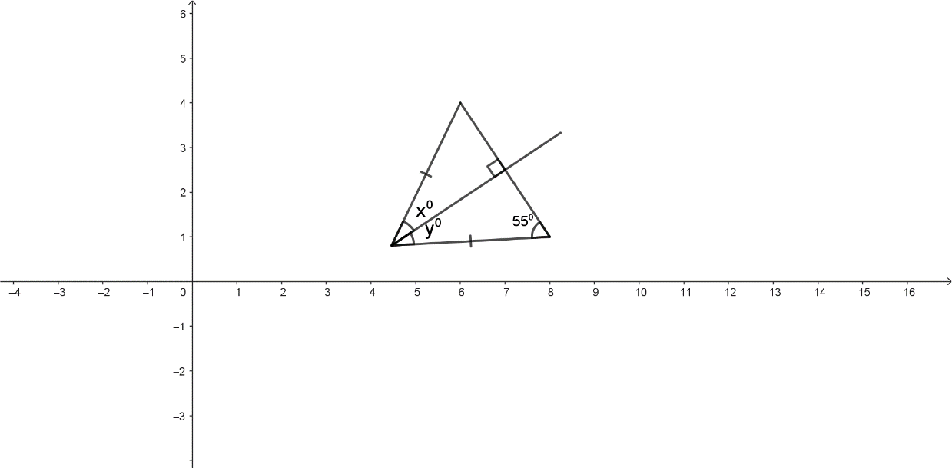Factorize : $x^{4}-x^{2}-9-2a^{2}x^{2}+a^{4}+6x$ [2]
29. One side of $∆ABC$ is extended:
30. Draw the two triangles ABC of different sizes and experimentally verify that the relationship between the exterior angle and the sum of non- adjacent interior angles. [3]
31. Find the value of $x° and y°$. [1]
32. 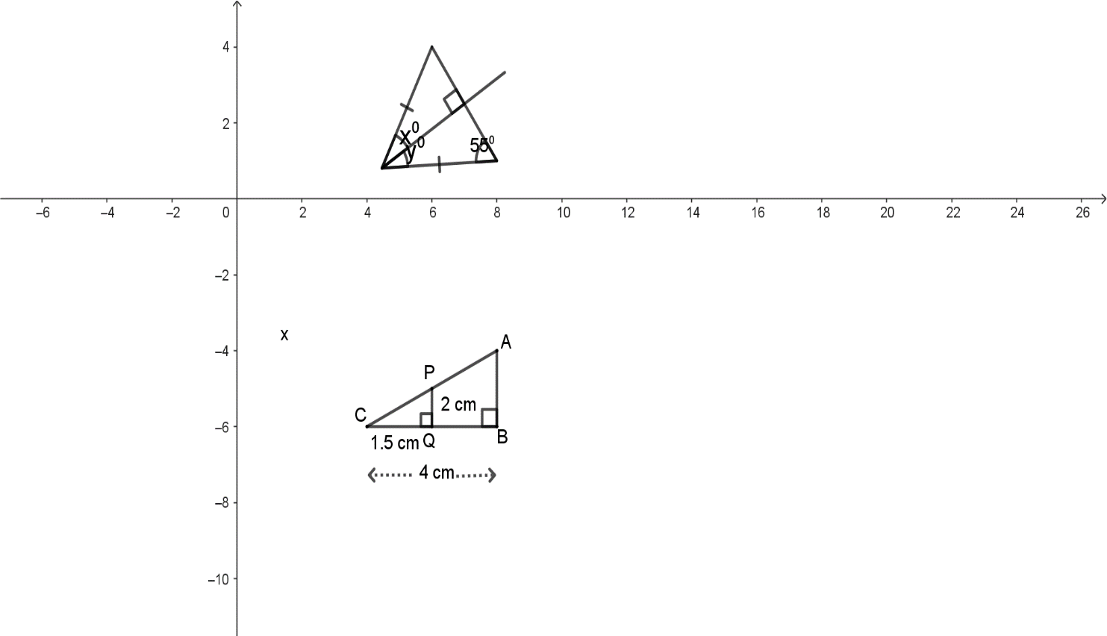a) Verify experimentally that in a triangle, the opposite to the longer side is greater than the angle opposite to the shortest side. [3]

b) In the adjoining figure, $∆ABC\sim ∆CPQ$ and PQ= 2cm, CQ = 1.5 cm and CB 4 cm. Find the value of . [2]

11. The marks obtained by 45 students in the first term exam of class 9 in mathematics is given below:

|  |  |  |  |  |  |  |  |
| --- | --- | --- | --- | --- | --- | --- | --- |
| Marks Obtained | 20-30 | 30-40 | 40-50 | 50-60 | 60-70 | 70-80 | 80-90 |
| No. of Students | 5 | 7 | 9 | 10 | 8 | 4 | 2 |

1. In which series is the given data presented? [1]
2. Construct the cumulative frequency curve. [2]
3. Find the number of students who have obtained more than 60 marks. [1]

Best of Luck.